Transition News 1
March 2024

Welcome to the Alderman White School family and to your first Transition Newsletter. We are very excited to get to know you all over the coming months.
It is very important that you remember to contact Nottinghamshire County Council to ‘accept’ your place at the school. If you have not done so already, please do this as a matter of priority.
You will receive regular contact from us via email throughout the remainder of this academic year, so it is important that we ensure we have your most convenient email address. Please contact the school on 0115 9170424 or email our school administrator: heather.crofts@whptrust.org to update this, as necessary. This way, we can ensure together that you will not be missing out on any important information. You can also contact any of the transition team should you have any queries or feel the need to share any important information at this stage directly via:
mandy.holling@whptrust.org Assistant Headteacher - Personal Development and Transition Lead
patricia.padley@whptrust.org School SENDCo
Your next email will contain a link to an online form to complete the required Student Personal Details and contact information. This is likely to be the first week back after the Easter break (week beginning 15th April 2024). If you do not receive this email by Friday 19th April, or require a paper copy to complete, please contact the school. Please complete this information as soon as possible.
This newsletter is to welcome you into the Alderman White Community and start to guide you through the transition process.
We are very much looking forward to running our induction programme in July, including an Induction Evening for parents/carers where you will have the opportunity to meet key staff and gather all the relevant information you require. Further details will be sent out in due course.

The important dates for your diary currently are:

Year 6 Welcome Evening for parents/carers and students: Wednesday 24th April 2024 – School Hall
(NB: If your child’s current primary school does not appear on this list, please feel free to attend either session but let the school office know: white@whptrust.org.uk)

5.30pm | Round Hill Primary  Bramcote C of E Primary  Bramcote Hills Primary  The Lanes Primary  Chetwynd Spencer Academy  Akaal Primary School  Fernwood Primary School  Nottingham High School
6.15pm | Eskdale Junior  Beeston Fields Junior  John Clifford Primary  Sunnyside Spencer Academy  All Hallows C of E Primary School  Harrington Junior School  Wadsworth Fields Primary School

Year 6 Induction days for students: Tuesday 2nd July 2024
Wednesday 3rd July 2024
Thursday 4th July 2024

Year 6 Induction evening for students & parents: Wednesday 3rd July 2024 (6:30pm - 8:00pm)
Preparation — What can parents and students do?
- Visit our website, join our school/transition/www.aldermanwhite.school. Here you will find valuable information (particularly in the transition section) as well as school policies.
- Parents: ‘Like’ and follow us on Facebook for up-to-date feeds.
- Make a note of Mrs Holling’s email in case you have any questions/queries.

Ctrl and double click on the link below to access the Alderman White YouTube channel. Here you will find a variety of performances from our wonderful students.

Alderman White YouTube Channel

Our School Values:

Our sense of community is based around our INSPIRE values of integrity, nurture, success, perseverance, innovation, responsibility, and engagement. Every member of our school community is encouraged to embrace these values and to demonstrate them through their attitude and conduct both within school and in the wider community.

A community of opportunity for all

It would be great to start getting to know our new year 7’s so we have produced some activities that we would like year 6 to have a go at:

The Task: #ThisisMe

Create a portfolio (a collection) of information to either bring to the school when you visit or email mandy.holling@whptrust.org

Your portfolio should include:

- An introduction to yourself (what you would like us to know about you!)
- A letter to your Year 6 class teacher about the best things about your time at primary school (events/trips/lessons/teachers etc.). We will be sending these on once you have started at Alderman White.
- Your favourite specialist subject – a chance to show off everything you know about a hobby or subject you love to your new teachers.
- What you are most looking forward to about starting at Alderman White school.
- A map of your journey to our school (including buses/trams/stops/timings etc.)
- A letter to your new Year 7 tutor about why you will be a fantastic addition to their tutor group and the Alderman White Community.

Your portfolio can be presented in any way you choose. Try to be creative and innovative (you may wish to look this word up in a dictionary?)
The due date for your portfolio is: Thursday 4th July 2024.
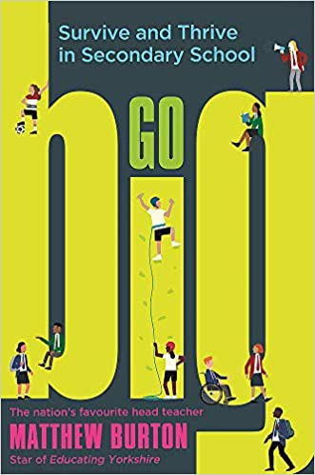
Recommended resource to aid transition:
This fantastic book, ‘Go Big’ by a former Headteacher and star of Educating Yorkshire, Mr Matthew Burton, is a great read and has many ideas, tips, and advice on starting secondary school. It is not a compulsory purchase, just a read that some of you may find interesting.
We will be in touch again soon…

Mrs Holling
Assistant Headteacher – Personal Development and Transition

